SAFETY EXPERTS
Shop No. 4614-15 Gali Shahtara,Ajmeri Gate Delhi -6
Ph.011-23215050, 30114467, 43517483
E-Mail -Rahulsakhuja@yahoo.com

MICRO SAFETY TORCH
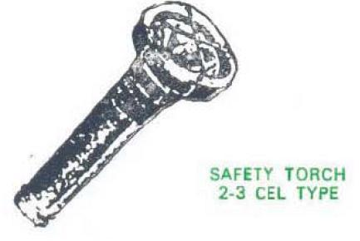
WHY OUR SAFETY TORCHES ARE SO POPULAR….
THAT PEOPLE ARE TEMPTED TO MAKE its DOPLICATE
BUT ARE NOT SUCCESSFUL…………
We are one of the leading organizations engaged in providing excellent quality 2-3 Cell Type Safety Torches, which are manufactured by using high grade material.
Features of our 2-3 Cel Type Safety Torches are:-
* Attractive Power coated Brass Body.
* Robust construction.
* Highest light output among the different make available due to special design and strict quality control of chromium plated brass refectory.
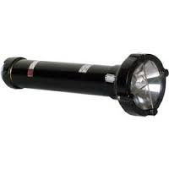
* Optimum weight to achieve both sturdiness and strain free handling.
* Totally free from usage of M.S. parts.
* Dual action switch is provided to make the torch either temporarily or permanently 'ON'.
* Switch design is or screw type such that there will be a gap of at least 5 mm between two contact surface when torch is not in use. This prevents the leakage of cells giving more life to the costlier cells. * Circuit resistance is almost negligible with the result power consumption is low. * The strict quality controls of all components makes our torch acceptable by all the industries as well as trade people. * The torch is tested and approved by cmrs dhanbad as intrinsically safe torch as per is 5780-1980. * In addition to above OUR torches are also weatherproof in design. * we always keep on looking for better quality and invite suggestion from users and try to implement the same if possible.
High in demand, these 2-3 Cell Type Safety Torches are available at most reasonable prices

